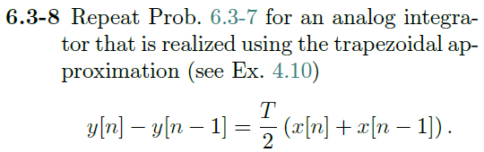

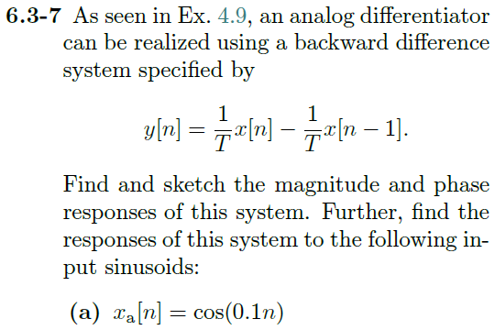

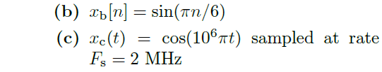

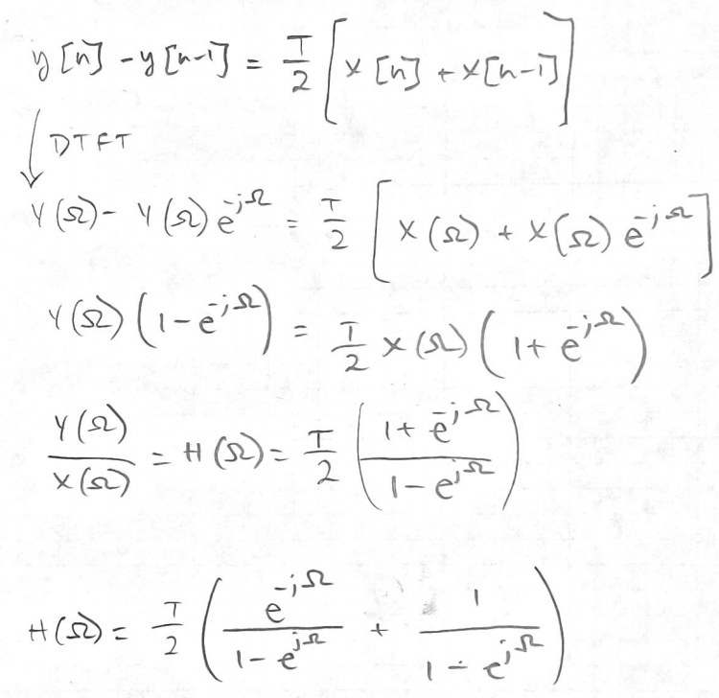

Then in MATLAB, with a period T = 1

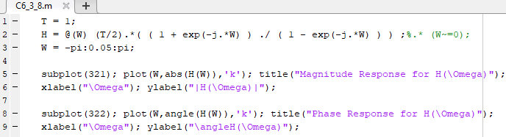

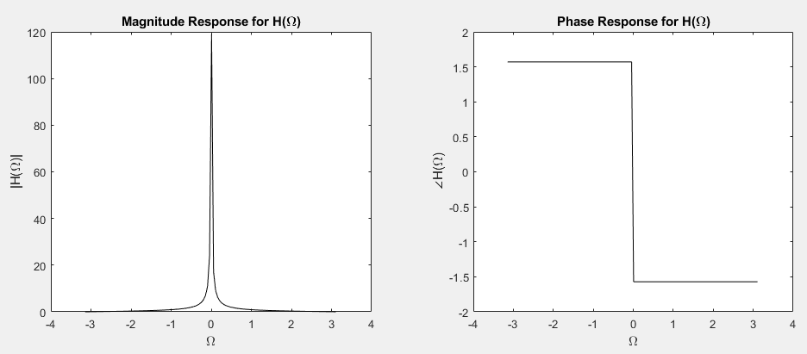

**a) $x_{a}\left[n\right]=cos⁡(0.1n)$**

$$T=\frac{2π}{ω}=20π$$

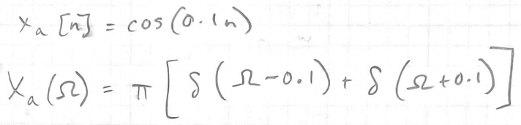

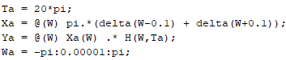

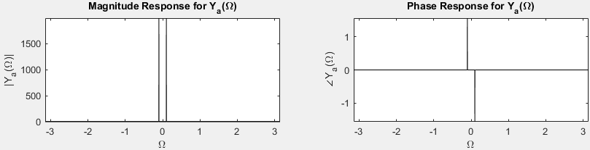

**b) $x_{b}\left[n\right]=\sin\left(\frac{πn}{6}\right)$**

$$T=\frac{2π}{ω}=12$$

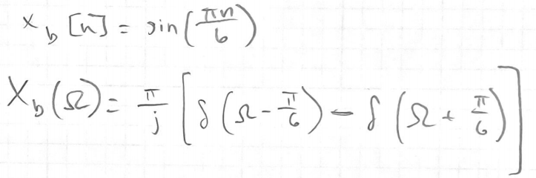

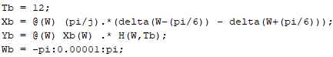

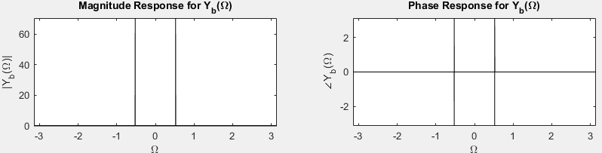

**c) $x_{c}\left(t\right)=\cos\left({10}^{6}πt\right) sampled at F_{s}=2MHz$**

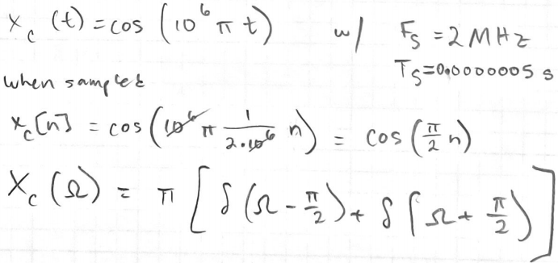

$$T=\frac{2π}{ω}=4$$

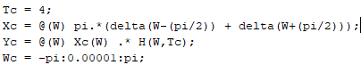

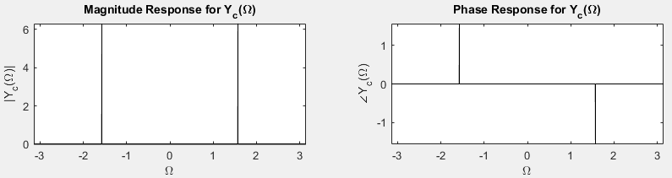

MATLAB

H = @(W,T) (T/2).*( ( 1 + exp(-j.*W) ) ./ ( 1 - exp(-j.*W) ) ) .* (W~=0);

W = -pi:0.025:pi;

T = 1;

subplot(421); plot(W,abs(H(W,T)),'k'); title("Magnitude Response for H(\Omega)");

xlabel("\Omega"); ylabel("|H(\Omega)|");

subplot(422); plot(W,angle(H(W,T)),'k'); title("Phase Response for H(\Omega)");

xlabel("\Omega"); ylabel("\angleH(\Omega)");

delta = @(w) (w<=0.001 & w>=-0.001);

Ta = 20*pi;

Xa = @(W) pi.*(delta(W-0.1) + delta(W+0.1));

Ya = @(W) Xa(W) .* H(W,Ta);

Wa = -pi:0.00001:pi;

Tb = 12;

Xb = @(W) (pi/j).*(delta(W-(pi/6)) - delta(W+(pi/6)));

Yb = @(W) Xb(W) .* H(W,Tb);

Wb = -pi:0.00001:pi;

Tc = 4;

Xc = @(W) pi.*(delta(W-(pi/2)) + delta(W+(pi/2)));

Yc = @(W) Xc(W) .* H(W,Tc);

Wc = -pi:0.00001:pi;

subplot(423); plot(Wa,abs(Ya(Wa)),'k'); title("Magnitude Response for Y_a(\Omega)");

xlabel("\Omega"); ylabel("|Y_a(\Omega)|"); axis tight;

subplot(424); plot(Wa,angle(Ya(Wa)),'k'); title("Phase Response for Y_a(\Omega)");

xlabel("\Omega"); ylabel("\angleY_a(\Omega)"); axis tight;

subplot(425); plot(Wb,abs(Yb(Wb)),'k'); title("Magnitude Response for Y_b(\Omega)");

xlabel("\Omega"); ylabel("|Y_b(\Omega)|"); axis tight;

subplot(426); plot(Wb,angle(Yb(Wb)),'k'); title("Phase Response for Y_b(\Omega)");

xlabel("\Omega"); ylabel("\angleY_b(\Omega)"); axis tight;

subplot(427); plot(Wc,abs(Yc(Wc)),'k'); title("Magnitude Response for Y_c(\Omega)");

xlabel("\Omega"); ylabel("|Y_c(\Omega)|"); axis tight;

subplot(428); plot(Wc,angle(Yc(Wc)),'k'); title("Phase Response for Y_c(\Omega)");

xlabel("\Omega"); ylabel("\angleY_c(\Omega)"); axis tight;